i

**Contents**

|  |  |  |  |
| --- | --- | --- | --- |
| **Sr. No.** | **Topic** | | **Page No.** |
|  |  | |  |
|  |  | |  |
|  |  | |  |
|  | **Abstract** | | i |
|  |  | |  |
| **Chapter-1** | **Introduction** | | 1 |
|  | 1.1 | Introduction to Project | 1 |
|  | 1.2 | Problem Statement | 2 |
|  |  |  |  |
| **Chapter-2** | **Literature Review** | | 4 |
|  | 2.1 | Introduction | 4 |
|  | 2.2 | Existing methodologies | 5 |
|  | 2.3 | Proposed methodologies | 6 |
| **Chapter-3** | **Software Requirement Specification** | | 7 |
|  | 3.1 | Hardware Requirements | 7 |
|  | 3.2 | Software Requirements | 8 |
| **Chapter-4** | **Forms** | **Screenshots** |  |

**Abstract**

E-learning fulfils the thirst of knowledge and offers online content that can be delivered for the learner at anywhere, anytime and any age through a wide range of e-learning solution while compared with traditional learning system. It also provides the rapid access to specific knowledge and information. With the rapid growth of voluminous information sources and the time constraint the learning methodology has changed. Learners obtain knowledge through e-Learning systems rather than manually teaching and learning. In this research paper proposes the e-learning management system with web services oriented frame work and SOA. This system supports the cross browser and fully integrated with different databases. This system focused around the several features namely Content Management, Content Protection, Learning Management, Delivery Management, Evaluation management, Access Control, etc., and mainly focused on integrated platform needed for e-learning and managements.

**Introduction Chapter 1**

* 1. **INTRODUCTION TO PROJECT**

E-learning has become popular these days and number of lecturers and students are attracted towards the online learning methods. E-learning has started its evaluation from distance education methods, where the education is not done at a class room level . Distance learning has become successful due to many advantages like its flexibility, ease of use and learning from a remote location as well. Even the business aspects has raised a lot in E-learning and lot of returns are achieved based on E-learning business and it is around US$90 billion at the beginning of 2000.

Mostly e-learning is used by the adults who are already working in some organizations, they are learning for a better qualification with out neglecting their current job and also with out disturbing their earning capability. This e-learning is not only popular for the working employees it is also used by the students and some job searchers also.

In the younger generation e-learning had become a daily requirement as the technology and internet is spread throughout the world . The fact is that e-learning or online learning is generally used by the teenagers. Even though it is popular and most used, e-learning has few limitations. One of such limitations is learners who don’t have computer proficiency will use e-learning for attaining good knowledge as the e-learning mainly focuses on the computer technologies, but the learners who don’t have good computer skills will feel this as a barrier for them. The other limitation is, in e-learning the physical interaction among the learners will be limited .

**1.2 Problem Statement**

Developing a E-Learning Platform using Angular , Spring and Oracle Database where individuals such as Students and Working Professionals can Register and Enroll themselves for various courses and Up-skill themselves on different Frameworks and Programming Languages.

**Diagrams and SQL Tables Chapter 2**

**2.1 ER Diagram**

Course

Register

Feedback

Enroll

C_id

C_name

C_price

C_description

Subject

Message

User Email

User Name

ID

NAME

EMAIL ID

PHONE no

ADDRESS

User_ID

Course_Name

C_Price

Course_Desc

gives

Enrolls

Gender

DOB

Password

C_File

C_image

C_Image

**2.2 UML Diagram**

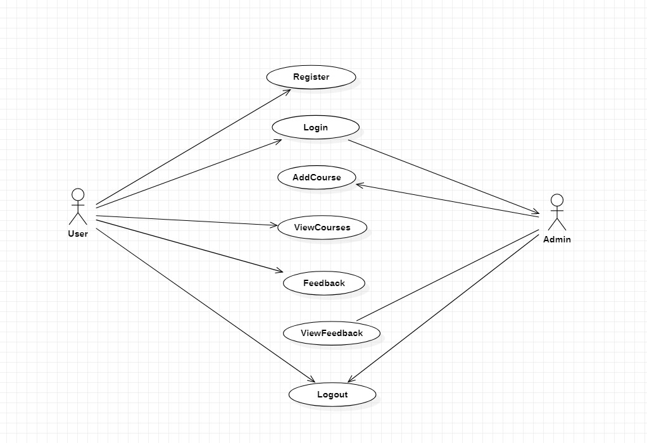

**2.3 DFD Level 0 Diagram**

User

ELearning

-Backend

Database

Request Data

Response

Registers and Login

Takes a Course

Admin

Adds Courses

Views Users/Courses/Feedback

**2.4 Database Tables**

1. **Register Table for User Registration:**

create table register (id number primary key, firstname varchar2(100), lastname varchar2(100) DOB varchar2(100), gender, phone number, email varchar2(100), username varcha2(100), password varchar2(100), confirmpassword varchar2(100));

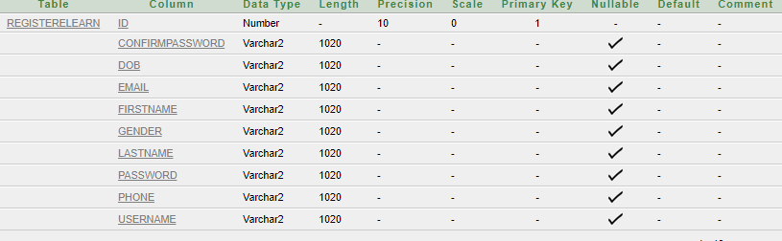

1. **Course Table for Courses:**

Create table course(Id number primary key, cfile varchar2(100) ,course_des varchar2(100), course_fees number, course_name varchar2(100), image varchar2(100))



1. **Feedback Table for Feedback from Users:**

Create table Feedback (id number primary key, messege varchar2(100), subject varchar2(100), user_email varchar2(100), user_name varchar2(100))

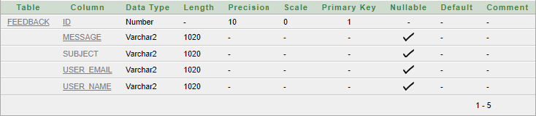

1. **Enroll Table for User Enrolled Courses:**

Create table enroll(id number primary key, cfile varchar2(100), course_des varchar2(100), course_fees varchar2(100), course_name varchar2(100), image varchar2(100), username varchar2(100))



**Frontend Working and Backend Structure Chapter 3**

4

**ScreenShots Chapter 4**

5

6

7

8

9

**Conclusion**

It is concluded that the application works well and satisfy the both registered and unregistered. The application is tested very well and errors are properly debugged. The site is simultaneously accessed from more than one system.

The site works according to the restrictions provided in their respective browsers. The speed of the transactions become more enough now. In this site the user can search the appropriate answers for their questions.. They can view their favorable questions, articles and inventions.

10

**References**

11